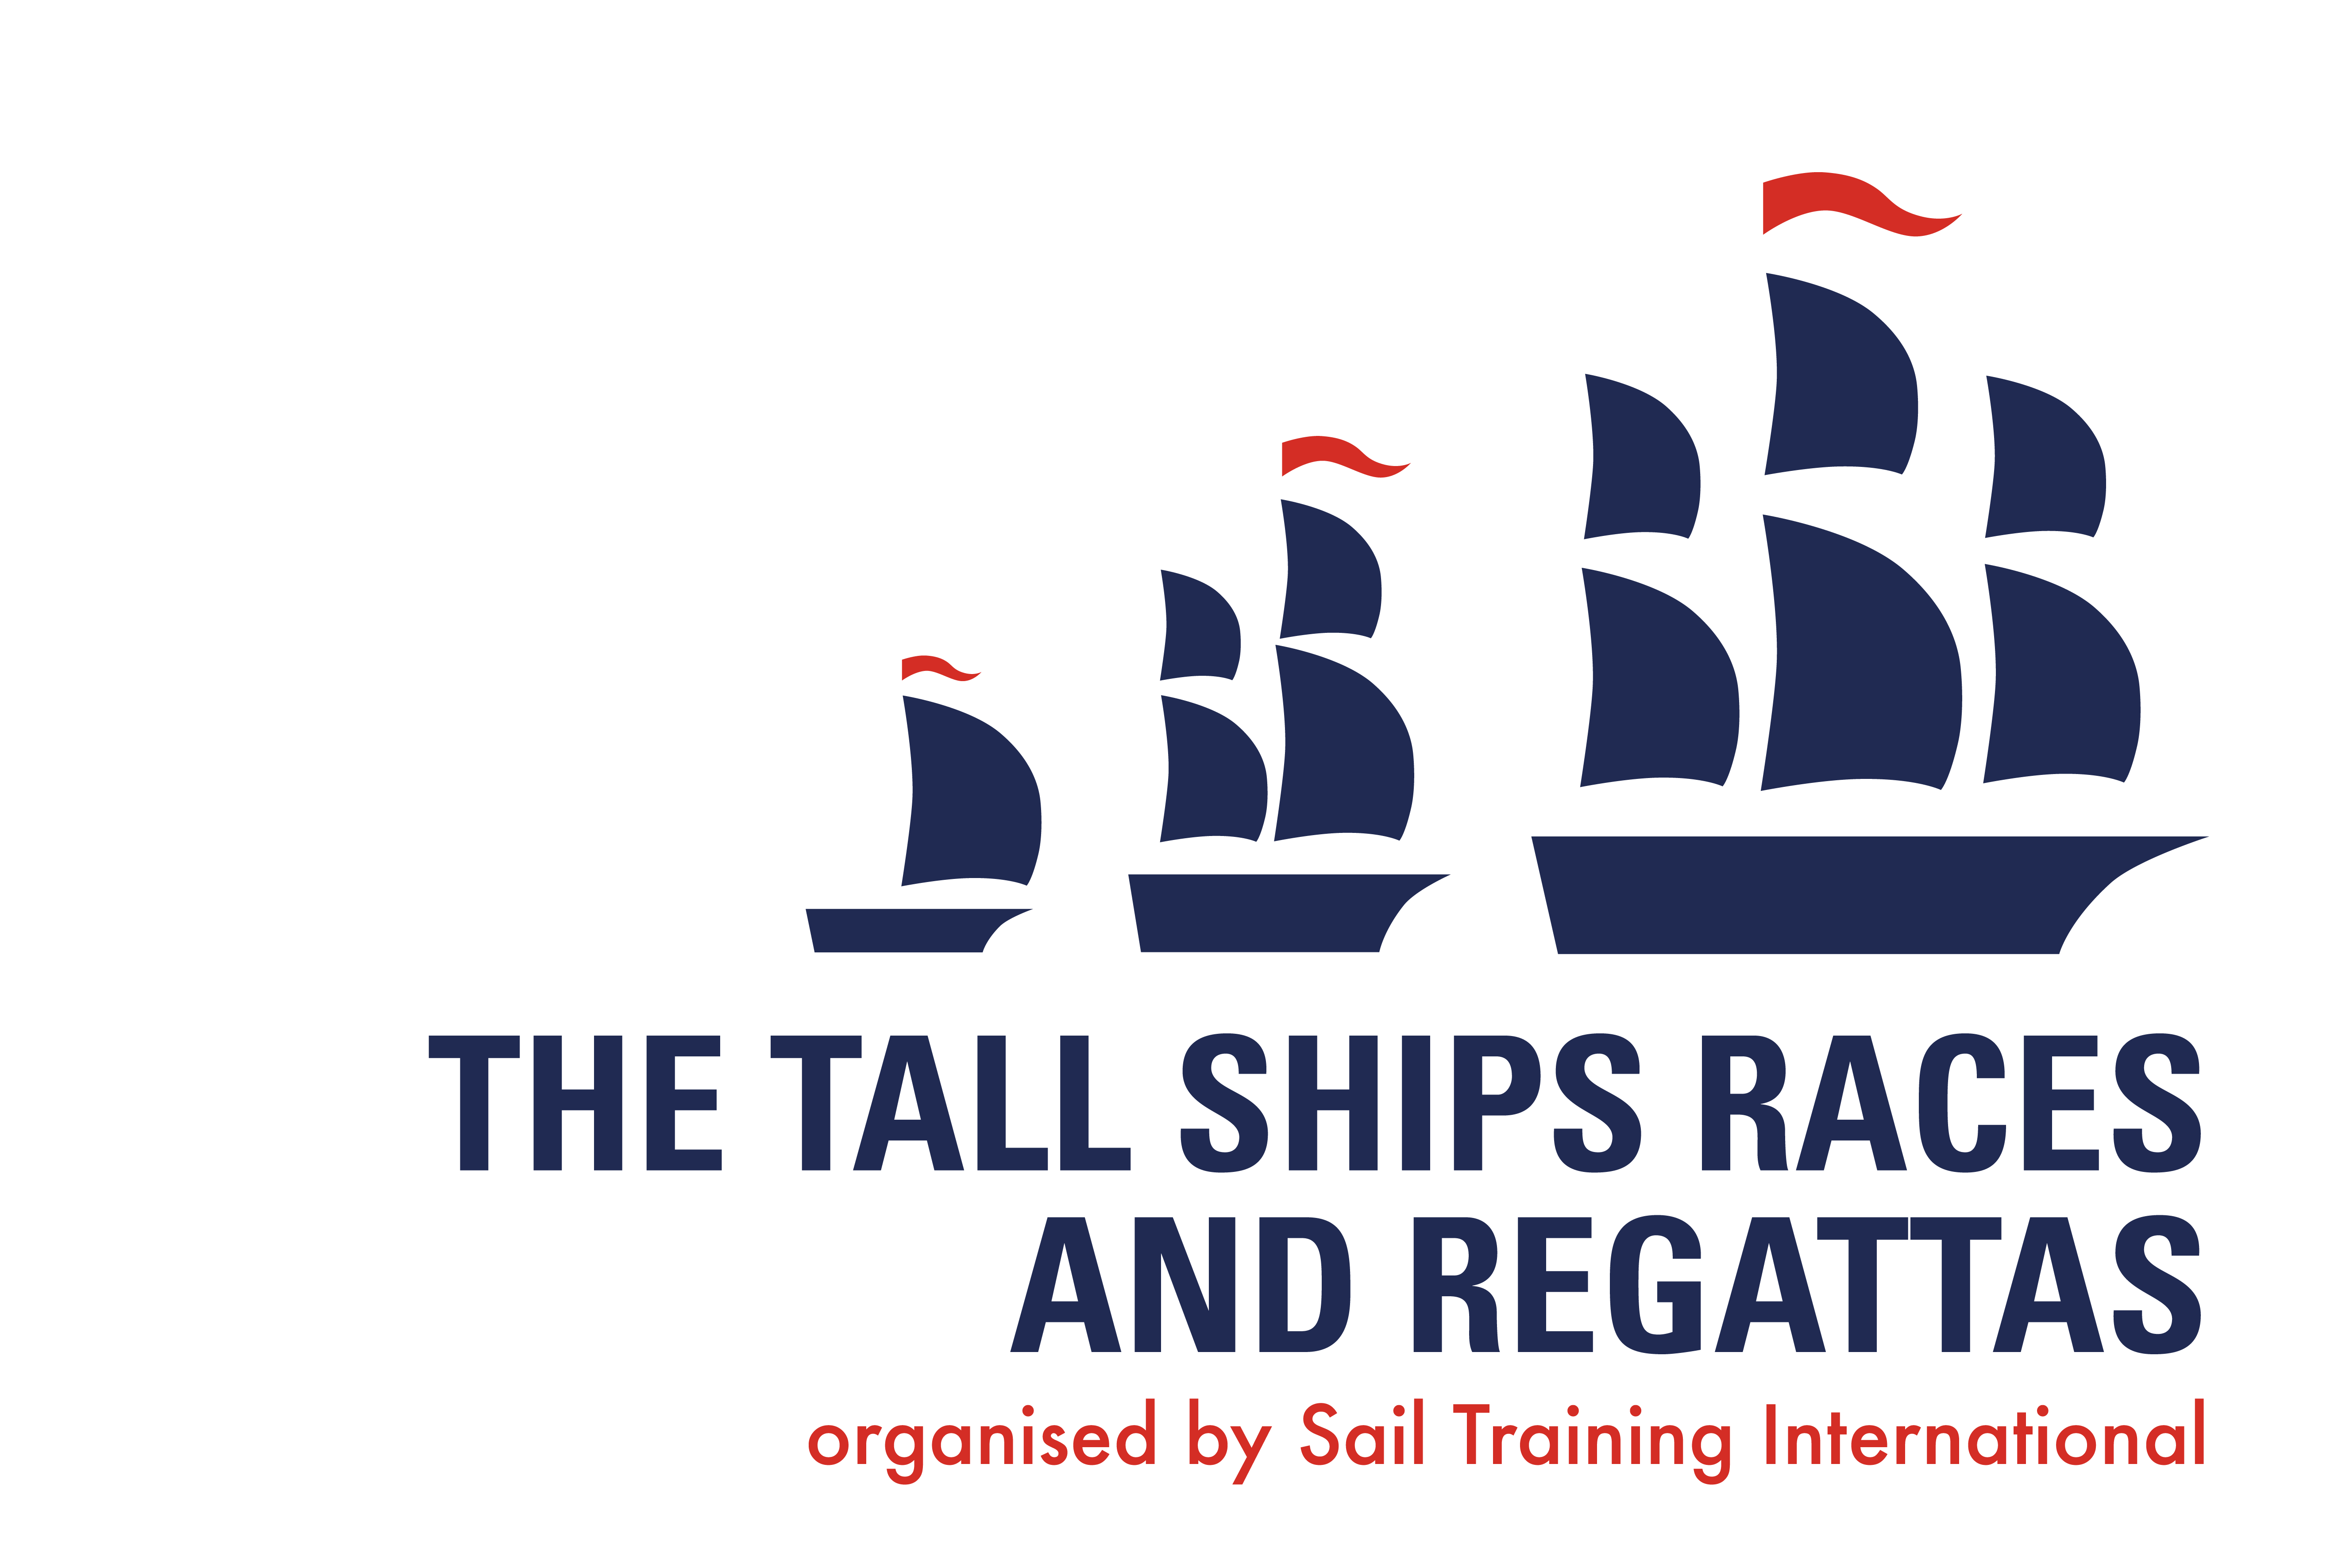

Name of addressee
Name of company
Address

Date

Dear (Name),

My name is … and I am writing to ask for your assistance in helping me to join a challenging sail training voyage on board.

Sail training uses the experience of being at sea to help young people, like me, discover hidden strengths, learn about themselves and understand the value of working as a team. It’s an activity that inspires self-confidence and personal responsibility. It also promotes an acceptance of others, whatever their social or cultural backgrounds, and develops a willingness to take controlled risks.

Those who undertake sail training on Tall Ships find it a positive, life changing experience. One the activity has a proven success in helping to develop young people to make a positive impact on society.

Sail training takes place all over the world and on many different types of vessel, and includes instruction in all aspects of sailing, but its purpose goes far beyond this. On both large and small vessels it provides challenges that require demanding work in both large and small teams.

To help with their running costs, vessels charge a fee to young people wanting to benefit from this experience and this is why I am writing to you today.

In return for any financial assistance your company may be able to offer towards my fee of €…, I will be writing an account of my experience and taking photographs to produce as an informative account of my time on board as part of (Name ship)’s crew. I would also be happy to help with appropriate PR.

If you would like to hear more about my voyage, you can contact me through the telephone number and email address provided in this letter. I would also be more than happy to come and meet with you to talk about my voyage in person.

Yours sincerely,

